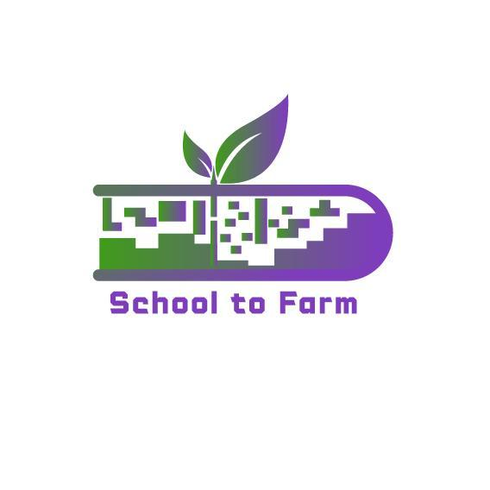

Using Farms as an Ecological and Pedagogical Education

Environment-Gamified-STEAM-Based Learning Approach

Model

**{SCHOOL TO FARM}**

**Good practices at Grundzāles pamatskola (Elementary school)**

2023

2022-1-PL01-KA220-SCH-000088981

**Placed based learning in the farm**

During the Career Week in October 3rd and 4th grade pupils of Grundzāles Primary School (Latvia) visited Grundzāles parish farm "Bērži".

In an interesting and attractive way, by asking questions and letting the children work practically, the farm owner Jānis Kuprišs told about the farm, which is engaged in dairy farming. The children learnt that there is a lot to learn and know in order to become a modern farm owner.

The pupils said that the most interesting thing was to see how the cows are milked by robots, that they show information about the cows on the computer and can even call the farmer if there is a problem, but the most fun were the little calves that could be cuddled.

|  |  |
| --- | --- |
|  |  |

|  |  |
| --- | --- |
|  |  |

**Be the change you want to see in the world!**

Place (or project) based learning - Water Day 22 March at Grundzāle Primary School

On World Water Day on 22 March, Grade 1 visited the Grundzāle shop to see the range of water available for purchase. In maths they studied bottle volumes and compared prices. In Latvian, they made sentences about water. In Science, they watched a video on how tap water is produced and how to use water wisely, and carried out various experiments with water. The children found out that water is expensive in the shops and resolved to save water at home and use more of it in their diet.

The pupils of 2nd grade shared their thoughts on the importance of water in human life and in nature, and watched the sand movie "The Tale of the Water Bear Laia" on the website. Each pupil completed a "Water Day" booklet during the week - looking for hidden words related to water, learning why and how much water to drink every day, taking the 5- day water challenge, writing or drawing about how they use water in their daily lives, and searching for folk songs, proverbs and water-related stories in the library books. In the classroom, the question arose - where does the water that runs through our taps start, where does the water that runs down the sink end up? This was clarified together with NKUP employee Jānis, who visited the treatment plant and the borehole.

Class 3 found out why we need to drink water, what role water plays in our body and in some of its organs, what are the signs of a lack of water in the body and how often and how much water we should drink during the day. To improve their health, Year 3 started a 30-day water drinking challenge.

In English lessons, Year 4 paired up to read a text and search for information on what Water Day is, why it is celebrated and what water problems are faced around the world. The students were amazed to learn some shocking facts: in some African countries, children cannot even go to school because they have to walk many kilometres every day to fetch drinking water. The pupils admitted that they had not even imagined how they could live in water scarcity and were looking for solutions to save water.

5th grade science lesson on "Water - the source of life, its quality is important for every living thing". The pupils discussed in groups, made posters about "good" and "bad" water, then presented them. They carried out an experiment using test papers to determine the nitrate, nitrite, hardness, carbonate, chlorine and ph levels of water we use every day, water from the Pals and melted snow. The conclusion is that we are responsible for the quality of our water and we must act in a way that does not pollute the environment. The children were happy to see that we have very good drinking water in the municipality.

After listening to an excerpt from the story "Winnie the Pooh and his Friends" by A. Milne, the pupils of 6th grade went to Palsa to play "Poohprunguli" - to measure the speed of the stream. The work was done in groups, after which the data was discussed and calculated.

Conclusion - to measure the speed of the current, the same rattles must be chosen and thrown far enough from the shore.

Class 7 summarised their water use habits and pledged to each take a water saving measure: take a shower instead of a bath; keep a water bottle in the fridge; do not run water when brushing your teeth. In order to know how water is obtained and purified in Grundzāle municipality, the pupils of the 7th grade in cooperation with the representative of

NKUP Jānis Graudiņš went to the place of water extraction and purification plants. The pupils were very interested in what the treatment plants looked like - nobody knew that biological bacteria need air circulation, otherwise they would die in 5 hours; that the biggest pests are dairy processors and beer producers; and the children from the Mēru Centre also learned why sometimes the water in their homes smells like sulphur.

In maths lessons, Years 7-9 calculated how many litres of water a household uses for different purposes. Each pupil was asked to work out at home the m3 of water used and the cost to the family per month. For most of the children, this was new information that had a real-life relevance. During the exchange of ideas, they concluded that the cleaner we want to be, the more water we will use. They shared their experiences on different ways of obtaining water as well as on sanitation systems.

In English, Year 9 pupils worked in groups to create posters with information on different water crisis issues. They searched for information in different texts to find solutions to the problems.

The only conclusion is that every small step together has great power and impact! Let's be aware and start using resources wisely!

|  |  |
| --- | --- |
|  |  |

|  |  |
| --- | --- |