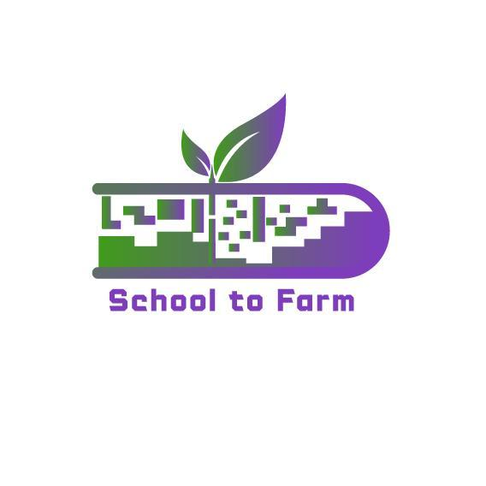

Using Farms as an Ecological and Pedagogical Education

Environment-Gamified-STEAM-Based Learning Approach

Model

**{SCHOOL TO FARM}**

**GOOD PRACTICES IN FINLAND**

2022-1-PL01-KA220-SCH-000088981

**Good Practice #1**

**Eco-schools in Finland**

Eco-Schools is the world's largest sustainable programme within the educational sector. More than 350 schools currently participate in the programme in Finland.

A version of the programme in English is available for international schools located in Finland.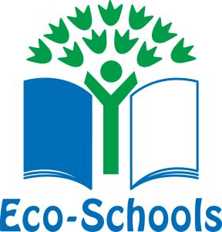

**The world's largest sustainable schools programme**

**Eco-Schools** is the world's largest sustainable schools programme. The programme operates in 68 countries, and has been run in Finland under the name Vihreä lippu (Green Flag) for more than 20 years. Currently there are more than 350 schools registered in the programme in Finland.

Eco-Schools empowers children to drive change and improve their environmental awareness through the simple Seven-Step framework in order to achieve the international Eco-Schools award. Eco Schools includes everyone, combines learning with hands-on experiences, improves the school environment and motivates and improves attitudes by challenging students to engage in tackling environmental problems at a level where they can see tangible results.

The programme’s greatest achievement is arguably the fact that it produces generation after generation of sustainably minded, environmentally conscious people. These individuals will carry the behavioural patterns they uptake under the auspices of Eco-Schools with them through life, in turn teaching the next generation the habits to make a difference.

## 

## International schools in Finland

FEE Suomi has customised the Eco Schools programme for the Finnish educational system. Most of their material is available in Finnish and Swedish.

English-speaking international schools located in Finland may join the programme as well, however following slightly different guidelines and materials, which have been tailored for international schools by the International Eco-Schools Programme.

### Costs of joining the programme

The cost for participating in the Eco-Schools programme in Finland is 550 € / year for schools with more than 100 pupils, or 275 € / year for schools with 100 or fewer pupils. The yearly levy covers administration, support and mentoring, resources and tools, as well as the Eco Schools certification.

**Eco-schools programmes in Finland and in other participant countries**

Programmes in Finland and in other countries differ, but they also have a lot of common guidelines, events and ideas.

A list of events, programmes, projects and materials can be found on the main website it this school:

<https://www.ecoschools.global/>

Finland's projects, materials can be found here:

<https://vihrealippu.fi/>

**One of the materials that is shared on Finland's Eco-School website is a guide to climate education**

Climate change is one [of the nine themes](https://vihrealippu.fi/materiaalit) of the Green Flag. In addition to the material aimed at participants, they offer the open materials on this page for all educators and teachers to use freely.

The material, which is open to everyone, includes “A Small Guide Little to Climate Education”, as well as material aimed at middle schools and secondary schools with lesson plans, videos, assignments, etc.

## A Small Guide to Climate Education

“A Small Guide Little to Climate Education” offers concise advice for successful climate education and handling climate emotions, as well as inspiring action tips.

Successful climate education includes knowledge, feelings, values, attitudes, skills and actions. At its centre is everyone's participation and working together.

They have made the guide with the support of Atea Finland Oy .

“A Small Guide Little to Climate Education” is a short summary [of the climate change theme material](https://intra.vihrealippu.fi/teemat/ilmastonmuutos/) offered to Green Flag participants, which provides comprehensive information and action tips for dealing with climate change with children and young people of different ages.

The article and materials can be found here:

<https://vihrealippu.fi/ilmastokasvatus/>

**Good Practice #2**

**Model Vihti**

This model, which is used by different primary schools (most students aged 7-12) and some pre-schools, has the aim to foster sustainable attitudes and an understanding of processes involved in the production of food by means of nature-connected education. Activities involve working in the school garden (children plan the season, grow plants, gather yield, etc. and products are later used in everyday school life), school-farm collaborations during which pupils and teachers work on different tasks on local farms, and learning in nearby forests (e.g., about forestry, water systems, climate change, but also first aid, making a safe fire, etc).

The school cooperates with parents and community experts like hunters or nature protectors. Positive outcomes of these projects are feelings of community between the school and its neighbourhood, and students deepening their knowledge with hands-on experiences.

Development project “Model Vihti” is a complete model to enlarge the learning environment outside of the classroom. At the moment it has been built to serve all primary schools in Vihti and serves as well the daycare and pre-school children in the same schools.

**By whom and for whom?**

This ILE is a learning organisation led by project facilitators in collaboration with schools, all main officials in Vihti Municipality (youth and leisure, culture, environment, education and pre-primary education) and local NGOs such as 4H and The Martha Organization. The approach in "Model Vihti" is to build up a learning environment outdoors to be in function year by year without special funding or fees, to be a part of everyday school work year around in all seasons.

This ILE has strong aims to give children better possibilities in the future for sustainable attitudes in adulthood to deal with everyday life: learning by doing and by experience gives meaning for academic lessons in the classroom. Learning outdoors is a holistic process with an urgent need to collaborate with other students e.g. in a garden, farm or forest. The hands-on education gives children skills and knowledge to understand deeper meanings of the knowledge learnt inside and from the book. Environmental settings nearby school include the social contacts with people living and working in the neighbourhood of school, to give a new approach to learning. Social capital is emphasising the community capacity by this ILE.

The ILE is aimed for all schools in Vihti and to the daycare in school sites. The learning environment outdoors is important as well for the after school activities organised by municipality for 1-2 nd grade children. It means age of 3-12 years in some schools but mostly age 7-12 at the moment. The model is possible to have in action as well for the age groups of 13-18 years but this project stage is mostly working with primary schools grades 1-6. All schools in Vihti are eligible to take part.

“Model Vihti” has its roots in NGO work by Vihti 4H- association. International 4H-motto is learning by doing and the four H mean: hands, head, heart, and health.

The facilitators have been working with this development process from the beginning 2003 and still continuing. New forces are coming along. The most important factor in Model Vihti is the “leading” teacher or principal in the school, the process goes on with minimum output from project facilitators when teachers and principals have got the idea to everyday school work.

All the workers take part in planning and guiding school-farm days, forest days and gardening when necessary. Teachers' training and contacts with schools are divided equally as well.

**Learning context**

“Model Vihti” enlarges the learning context out of the classroom into the nearby environment. It works as well with nature based environmental art education in these physical environments.

The main parts in the model are:

1) School garden;

2) Farm (as nearby the school as possible);

3) Forest and the water areas around the schools, incl. parks etc.

1) All schools have a small garden plot to cultivate; mostly it is used by the 3rd grade by spring time: planning the next season, growing plants indoors, preparing the soil, planting and sowing seeds before school holidays. In the autumn the same children are on 4th grade and they pick up the yield and prepare the soil for winter time. This garden is in wide use for all classes and subjects in the curriculum by other grades of the school.

2) School-Farm collaboration means the possibility to work and learn in the farm. Pupils are divided in groups with different tasks to be useful for the farmer: cleaning horses' boxes and equipments, doing the work needed at the moment like carrying firewood to storage etc. Children learn how much is needed to produce food, how nature is playing a part in every stage in cultivation and agriculture, their work is important and meaningful, children and teachers and farmers get feelings of success and learn to work mutually together.

3) Nearby forest is a place to learn the basics of forestry in Finland, the balance of nature, get knowledge of the water system, climate change and work towards it in sustainable manners. This part also includes the principles of first aid, acting in cold circumstances, making up a safe fire in the forest, using trangias, the roles of everyman's rights in Finland etc.

A fuller explanation of the “Model Vihti”:

<https://www.oecd.org/education/ceri/49750537.pdf>

Website of Vihti municipality:

<https://www.vihti.fi/>

Website of 4H Association in Finland:

<https://4h.fi/>

Website of The Martha Organization:

<https://www.martat.fi/>

Article of The Martha Organization in Finland about their project “Diverse home garden - Sustainable and edible home garden in the city project”:

<https://www.martat.fi/martat/marttajarjesto/kotitalousneuvonta/kohdennettuneuvonta/kotipiha/>