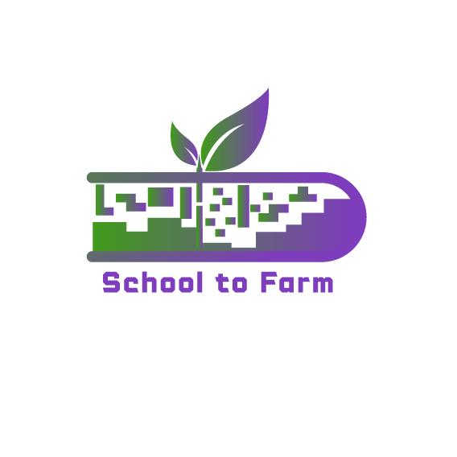

Using Farms as an Ecological and Pedagogical Education
Environment-Gamified-STEAM-Based Learning Approach
Model
{SCHOOL TO FARM}

GOOD PRACTICES IN GREECE

2022-1-PL01-KA220-SCH-000088981

Good Practice #1
Field Trip to Koukakis Dairy Farm
https://www.koukakisfarm.gr/
https://www.koukakisfarm.gr/blog/episkepsi-dimotikoy-sholeioy-ossas-sti-farma-koykaki
Koukakis Dairy Farm produces for several years now healthy and delicious dairy products. Their vision includes adherence to tradition, sensitivity fo the next generation, care for the Greek environnment and enriching the consumer table with top quality dairy products. Today, more than ever, their milk is completely fresh and comes directly from nature while being a 100% Greek, coming from Greek native animals fed with the farm’s own crops. The milk is produced without any methods that would reduce its quality and is collected, pasteurized and packed every day in order to maintain its nutrients.
Koukakis Farm is located in Kato Apostoli Kilkis, where clean air and absolute natural environment create ideal conditions for the development of crop production and breeding dairy cows.
Crop Production
The vertically integrated control over all stages of the chain from field to shelf, is the only way to ensure the highest quality of Koukakis Farm dairy products.
In the valley they cultivate durum and soft wheat, oats, barley, alfalfa, and cardoon. Fields are prepared by summer, immediately after the harvest of the previous growing season, in order to build the conditions for successful new production. The improvement of the fields requires soil analysis and fertilization with zeolite and digested manure which comes from the company’s privately owned farms. In this way, we avoid deterioration of groundwater.
The seeding of the fields begins every autumn with their own fleet of equipment and skilled personnel. In conventional farming, the application of fertilizer takes place, with modern machinery, to ensure the implementation of only the necessary amount of fertilizer. High quality certified seeds sowing will follow. Each summer, threshing and harvesting of the fields with grain and harvested forage plants takes place with the fully equipped fleet of Koukakis Farm machinery, achieving higher quality agricultural products, which in turn will create high-value animal feed.
In the context of integrated crop production, agro-1 and agro-2 standards, which are implemented by the family business, the further objectives of the company are ensured:
- Reduction of environmental pollution
- Burden reduction of human health, producer’s and consumer’s of the product
- Production of high quality agricultural products
Cows Breeding
On the basis of integrated milk management, Koukakis Farm breeds cows in its own facilities.
With the experience of Koukakis family in breeding animals and the combination of excellent technical training and scientific workforce, livestock raising quality is high. The modern milking facilities and stables ensure the welfare of our cows and their excellent health status, controlled intersections and high-quality cattle feed, and form the framework for producing highest quality milk.
All these in the valley of Kato Apostoli, a virgin environment in the heart of the Macedonian land.
School visits
Koukakis Farm welcomes elementary schools in order for children to become familiar with the production process of dairy milk and get educated on healthy nutrition.
Students walk around the farm to see and experience milk production, pasteurization process, milk bottling, yogurt production, as well as the production of other dairy products. Moreover, they have the chance to visit the cow farm and learn more on the breeding process and the importance of using fresh and natural products for feeding them in order to get the most nutritious milk.

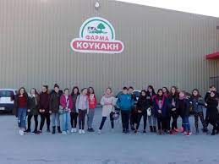
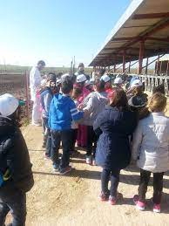

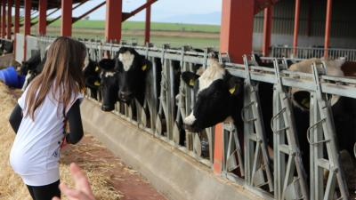
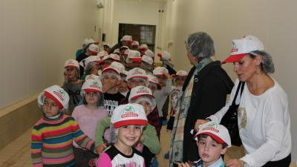

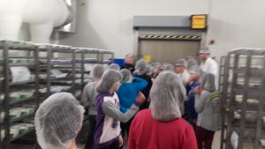
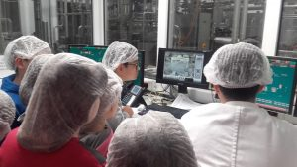

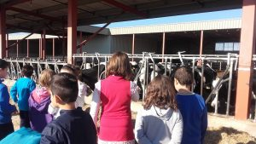

Good Practice #2
Summer on the Farm by the American Farm School
https://www.afs.edu.gr/afs.php?pg=121
"Summer on the Farm" is an educational-entertaining, intensely experiential, program implemented on the verdant farm of the American Farm School. Its aim is to offer children carefree days with games and experiences of collaboration, exploration, experimentation, discovery and approach to the land and its production, as well as the animal wealth of the farm.
Global environmental imperatives such as sustainable farming practices, the need to reduce food waste, material recycling, circular economy and climate change are reflected in experiential activities with gardening, cooking workshops, experiments, observation and animal care, "research trips" to other cultures, organizing youth businesses.
We thus create the stimuli to lead children to nutritional, environmental and social values.
The children's groups, organized into three age levels, implement a different educational-entertainment program every day, in outdoor shaded areas. Older children also have the opportunity for daily oral practice in the English language.
Program Description
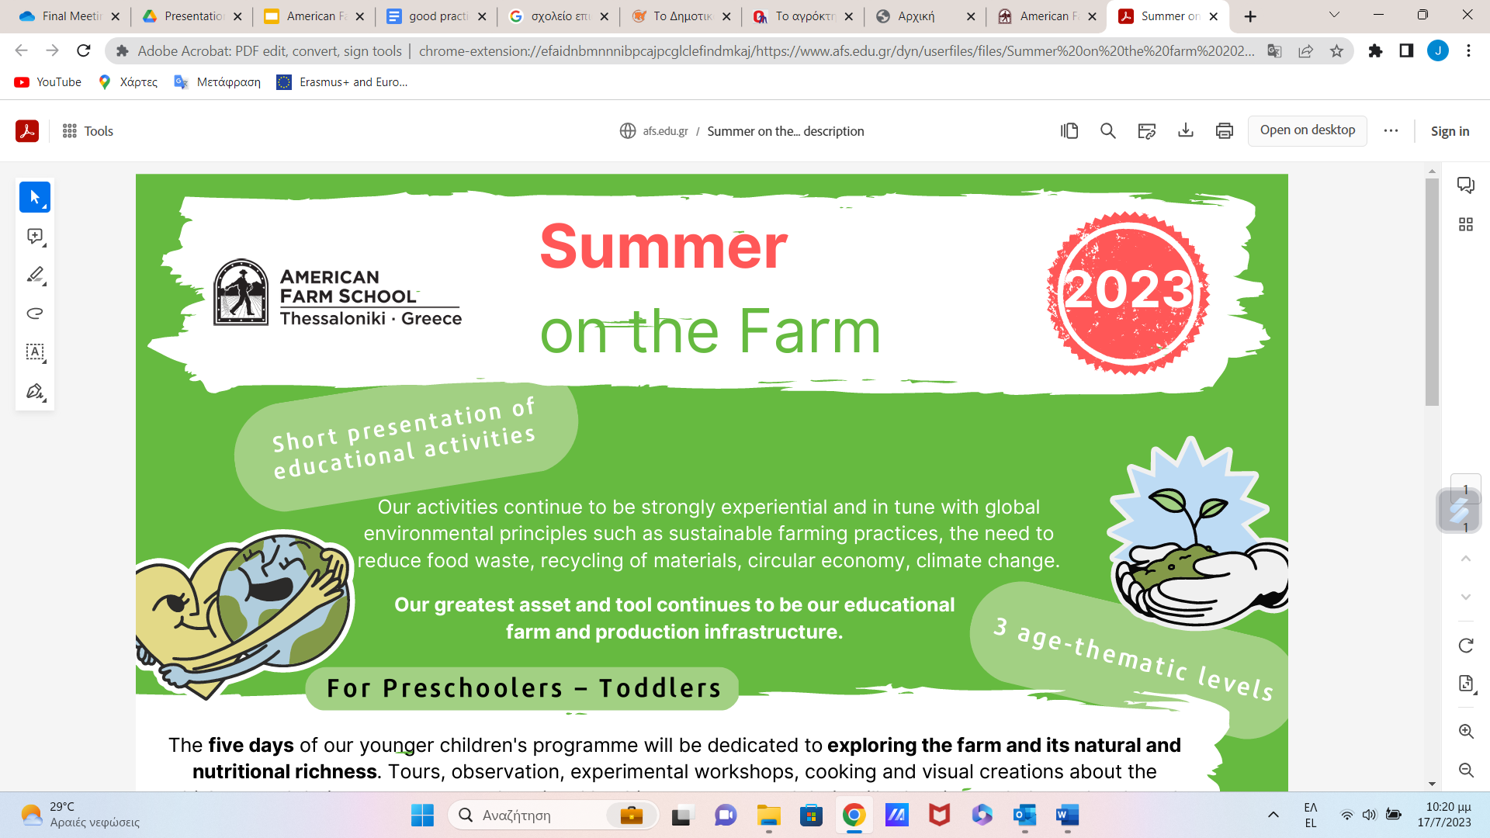

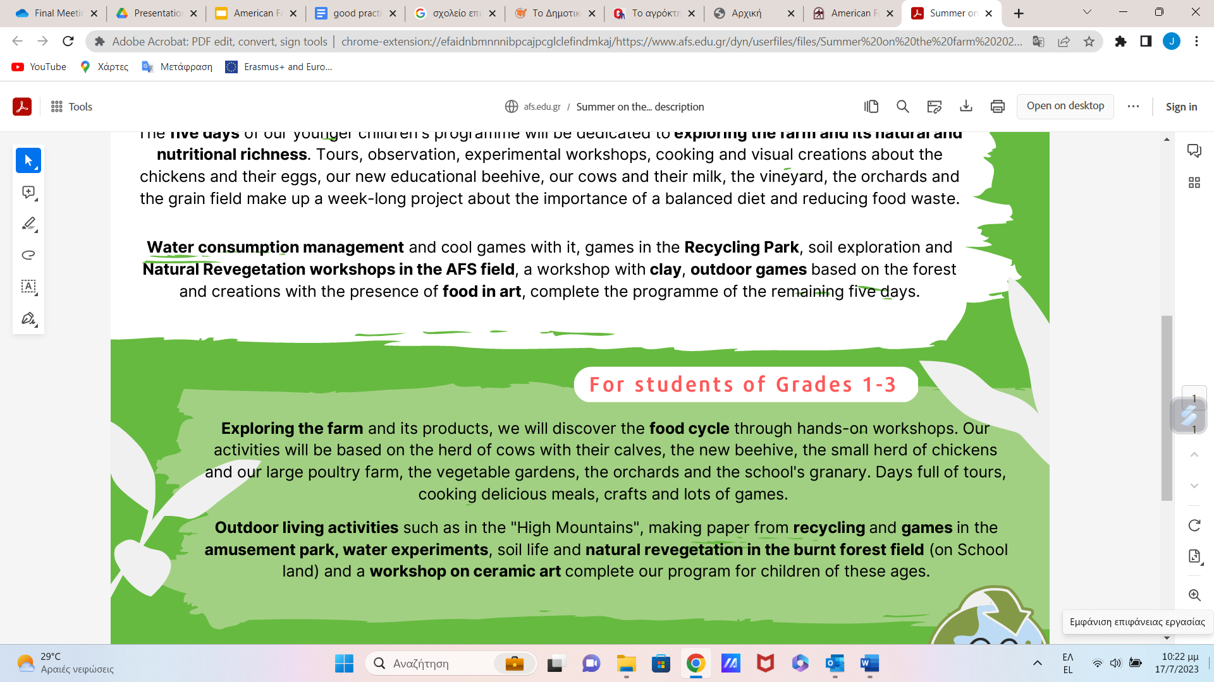
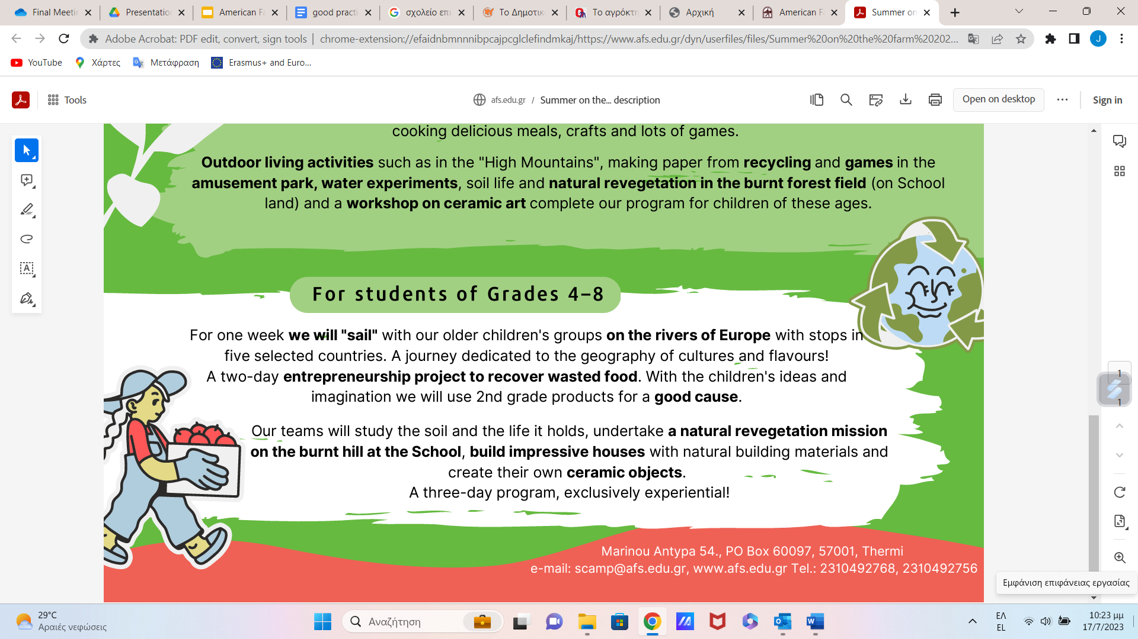

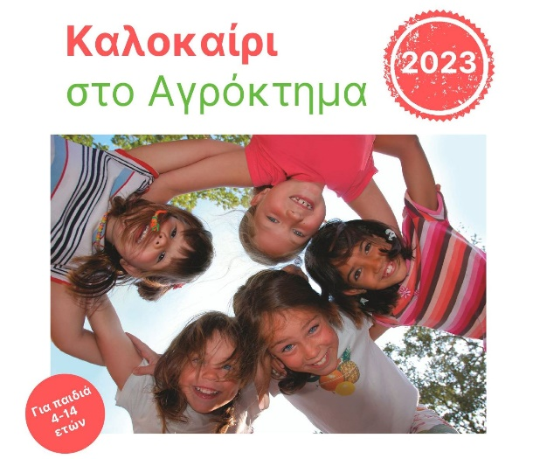
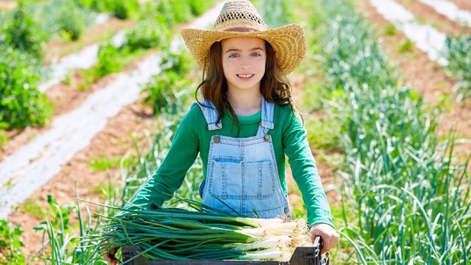

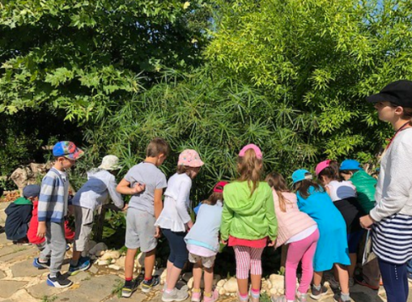
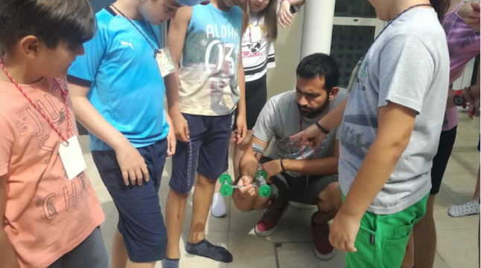

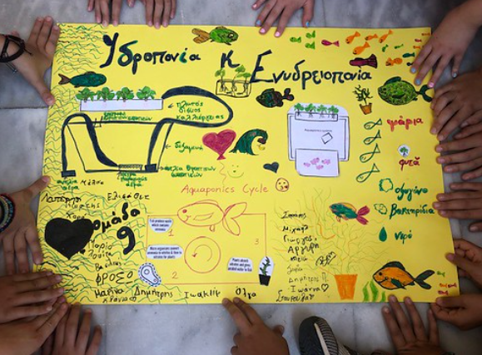
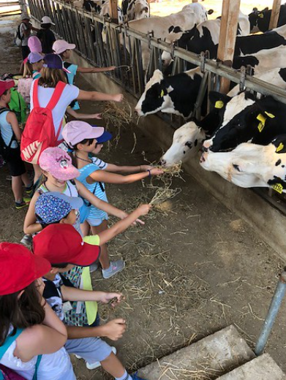

The American Farm School offers a number of Educational Experiential Programs and events on their farm and in town on weekends and during school vacations. Indicative Programs are:
- Birthday party at the farm
- Sunday morning at the Farm
- Special Saturday evenings at the Farm
- Festivities at the Farm

Good Practice #3
Field Trips to Vasilakos Farm – Organic Crops
https://www.sokratisvasilakos.gr/index.php
It is a model, original and alternative farm with social action and selfless offering!
It is privately owned, occupying an area of 28 acres and is located on the outskirts of the city of Karditsa, in its southern part, in the area of the Agios Panteleimonas district, near the former camps. It is only three kilometers from the city center and is connected by a main road being accessible not only by car or bicycle but also on foot.
The farm does not focus its activity only on obtaining some income, but rather on social contribution. So, in addition to the production of products, one can find there many other social activities, which are provided for free and which are rare to find in other farms.
From the year 2001 the farm opened its "Gates" and became open to visitors. Since then, many agencies, schools, and higher education institutions, as well as individual visitors, have been visiting the farm. It is accessible almost every day, but usually group visits are booked in advance. Individual visitors can visit the Farm every day and for all cases it is free!
Since 2015, an organic nursery for spring vegetables has been operating on the farm: eggplant, pepper, zucchini, cucumber, watermelon, melon and others. The nursery is legally licensed and cared for and supervised by two agronomists. The prices are affordable, while those who can not afford get the products free of charge.
Visitors are welcomed to stay overnight as well since there are some facilities but also they can use their own tent or trailer.
The owners of the farm also exchange their organic products for any services or products from third parties. They prefer organic products and the exchange can be done after discussion.
Students have the chance to learn about organic farming and get engaged in the farm’s activities. The owner, Mr. Vasilakos, makes the tour himself explaining the stages of cultivation and the advantages or organic fruits and vegetables not only to our health but also to the soil.

