LESSON PLANS

Module 1: Ecological Concepts and Definitions

Lesson Plan 1
LIVING SOIL
Proposed Students Age Range: 9-14
Purpose / Learning objectives
- Students are introduced to the concept of sustainability and sustainable agriculture.
- Students are ensured knowledge about sustainable agricultural practices and their environmental and social benefits.
Intersecting objectives
The following goals are grasped, and it is understood that sustainable agriculture is built in line with them:
- Reducing environmental damage while maintaining efficiency in agriculture,
- Ensuring the protection of natural resources,
- Prevention of environmental pollution,
- Producing high-quality products,
- Keeping the economy alive in the short and long term,
- To improve the quality of life of those engaged in agriculture and to develop practices for this purpose.

Facilitation
*Sustainable agriculture is explained based on the basic principles given below and students are expected to understand them:
- Getting knowledge about natural resources (soil condition, water resources, etc.)
- Knowing the environment (chemical waste, etc.)
- Managing features (dissemination of educational activities for sustainable agriculture)
- Knowing socioeconomic impacts (improving studies for the workforce)
- Long-term income of the producer
*To create a model of suitable and unsuitable agricultural land, it would be appropriate to prepare or explain visuals to show examples to students.
*It should be ensured that all materials are ready (internet, soil, etc.) before and it should be taken into consideration that the students and the classroom will get a little dirty.
*Make sure you always use recyclable or recycled materials.
Ideas for follow - up
With this lesson, students can learn the suitable conditions for sustainable agriculture. They can be able to distinguish eligible agricultural areas in nature.
Resources required
- Cardboard
- Wooden blocks/ wooden planks
- Play dough
- Miniature farm toys (animals, plants, farm equipment, etc.)
- Paint
- Pen
- Paper
- Container (for growing grass)
- Wheat seed
- Banana peel
- Scissors
- Fertile soil
- Infertile (lots of stones, etc.) soil
- Stone (pebbles)
- Water
- Watering can
- Internet
- Photograph
- Laptop, smart board etc.
Source / The day of the lesson: Materials & Class preparation
Prepared eligible and ineligible agricultural land model:

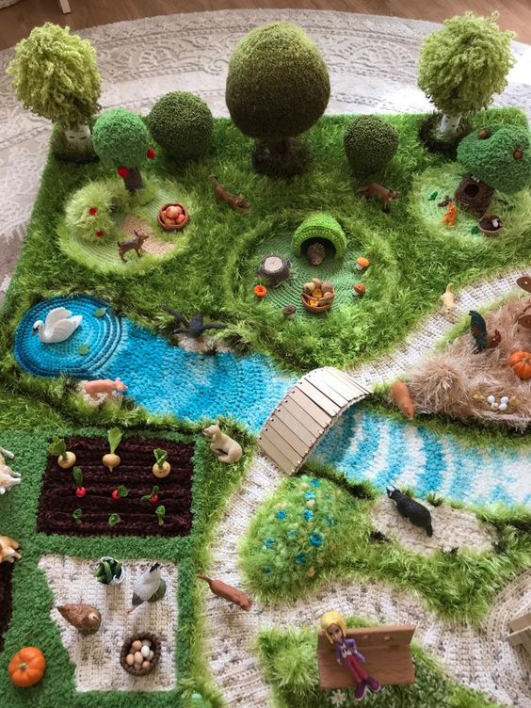

https://tr.pinterest.com/pin/516225176052097799/
https://www.livemaster.ru/mariya-gurgutsa

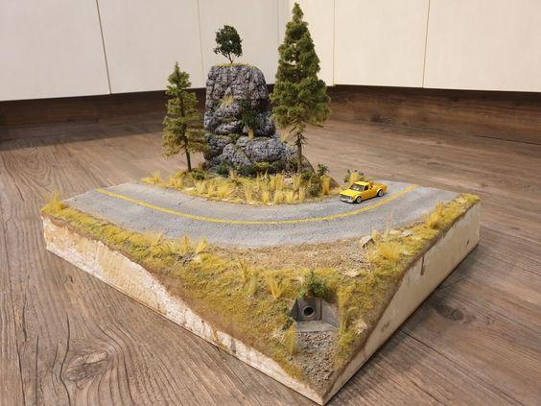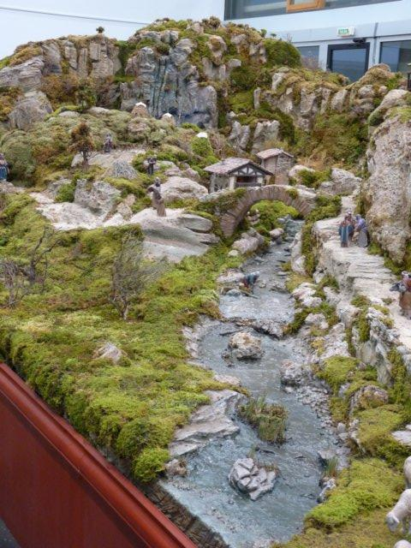

https://tr.pinterest.com/pin/28710516366831661/

http://www.arabelen.com/albumfotos/2008eb/2008eb.html

Computer games:
https://wordwall.net/tr/resource/14898556/tar%C4%B1m-%C3%BCr%C3%BCn

https://wordwall.net/resource/52081474/agriculture

Sustainable agriculture video:
https://www.youtube.com/watch?v=5SzJkL7czI0

Sustainable agriculture photos:
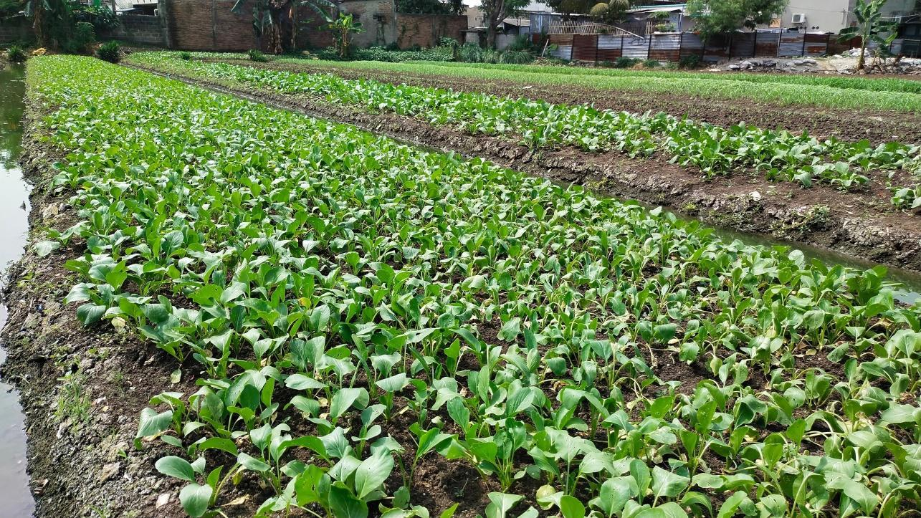
1: Eligible Agriculture
https://www.shutterstock.com/image-photo/agricultural-land-that-intended-suitable-be-2317670307

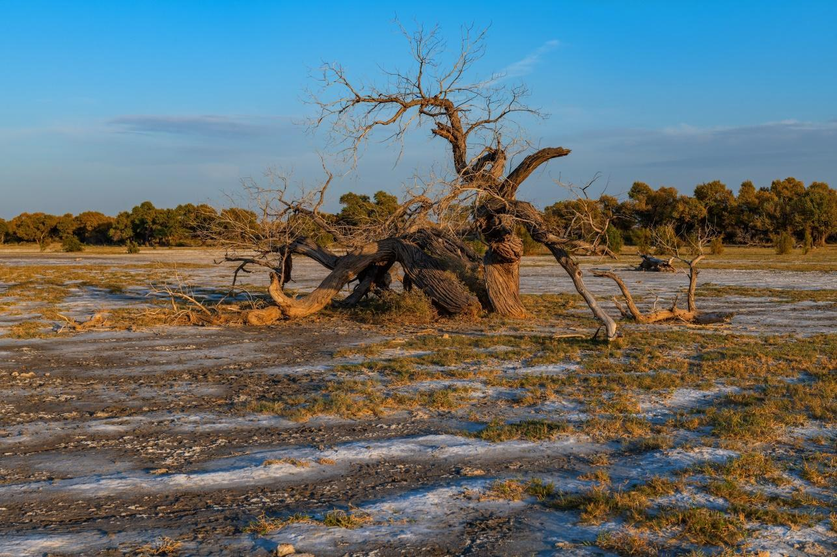
2: Ineligible Agriculture
https://www.shutterstock.com/image-photo/turanga-variety-poplar-on-soil-unsuitable-2210429981


3: Understanding Basic Principles of Eligible Agriculture
https://www.shutterstock.com/tr/image-photo/hand-planting-trees-technology-renewable-resources-2057392145



4: Growing Grass in Eligible Soil

https://www.shutterstock.com/tr/image-photo/farmer-his-son-front-sunset-agricultural-2188712163

Implementation

Timing | Instructions step by step
15 min | Pre-activity:  Ask students to  - What is agriculture?  - What is sustainability?  - What is sustainable agriculture?  - What do you think are the objectives of this lesson?  (These questions are asked to the students to get their opinions.)
25 min | - Introduce the concepts of sustainability and agriculture.  - Explain sustainable agriculture by using photographs.  - Screen a video explaining sustainable agriculture https://www.youtube.com/watch?v=5SzJkL7czI0  - Show pre-built models of eligible and ineligible agricultural land.  - Complete the lecture by facilitating discussion with students through these two models.
30 min | - Divide the class into individual groups  - Some of the groups are given fertile soil and some are given infertile soil, and each group is given wheat seeds (grass), a container and water and asked to plant.  - In order to make the soil more fertile,  Ask the members of the group to cut the banana peels they consume during class into small pieces and bury them in their soil.  - Over time, ask them to give sufficient water to fertile soil and less water to infertile soil.  - Ask the members of the group to share their opinions about grass growth in both soils and conditions in process time.  - Remind them that they observe the growth process of the grass for a week and the issue is discussed again.
20 min | - Engage students to play computer games related to sustainable agriculture.  https://wordwall.net/tr/resource/14898556/tar%C4%B1m-%C3%BCr%C3%BCn  https://wordwall.net/resource/52081474/agriculture (Please choose the country where the students live and play the game about the agricultural products of that country.)

Hands on activity / farm - based learning

Timing | Description of activity
25 min  30 min  20 min | Activity 1: The difference between eligible agricultural land and ineligible agricultural land is demonstrated with a model. Children are divided into groups and models are made in the classroom with the teacher’s support.  https://www.youtube.com/watch?v=5SzJkL7czI0  Activity 2: Children plant grass in different soil types. Half of the children experience fertile soil and half experience infertile soil.  Activity 3: A computer game on sustainable agriculture is played.  https://wordwall.net/tr/resource/14898556/tar%C4%B1m-%C3%BCr%C3%BCn  https://wordwall.net/resource/52081474/agriculture

Module 1: Ecological Concepts and Definitions

Lesson Plan 2
FELLOWS OF THE SOIL
Proposed Students Age Range: 9-13
Purpose / Learning objective
- Students are introduced to the concept of sustainability and sustainable agriculture.
- Students are taught how to use natural resources more efficiently within the scope of sustainable agricultural practices.
- Students are taught how water and light impact soil health by observing soil organisms and plant health in different conditions.
Intersecting objectives
● Increasing productivity in agriculture
● Ensuring the protection of natural resources
● Prevention of environmental pollution
● Producing high quality products
Facilitation
- It should be ensured that all materials are ready (internet, soil, etc.) before the lesson
- It should be taken into consideration that the students and the classroom will get a little dirty.
- Make sure you always use recyclable or recycled materials.
Ideas for follow -up
- Students can assimilate the importance of the ecological cycle and the place of natural resources in the cycle.
- Students can get better knowledge about understanding the concepts of recycling, savings and efficiency while evaluating their environment.
Resources required
● Grass seeds or small seedlings.
- Soil samples from the same source
● Water
● Transparent containers or jars (at least 6)
- Magnifying glass
● Light source (in front of a window, etc.)
● Notebook
- Labels or markers
● Pen
● Recycling materials (expansion forms collected in the classroom, such as EVA sponge, plastic bag, colored paper, fabric, stick, rope, etc.)
● Cork board
● Cork board pins
● Laptop, smart board, etc.
● Internet
● Drawing book
● Painting material
● Photos
Source / The day of the lesson: Materials & Class preparation
Word game:
https://app.lumi.education/content/6512943bbe3de7d68a77c85e
Water:

https://www.shutterstock.com/tr/image-photo/large-beautiful-drops-transparent-rain-water-668593321

Sunlight:
 https://www.shutterstock.com/tr/image-photo/spring-blossom-background-beautiful-nature-scene-1033292395

Soil:
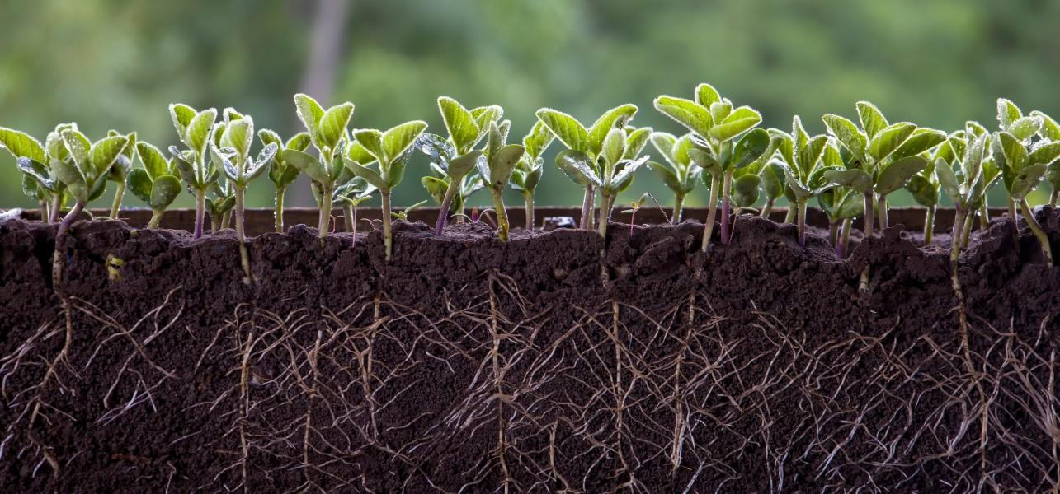
https://www.shutterstock.com/tr/image-photo/fresh-green-soybean-plants-roots-2183765863

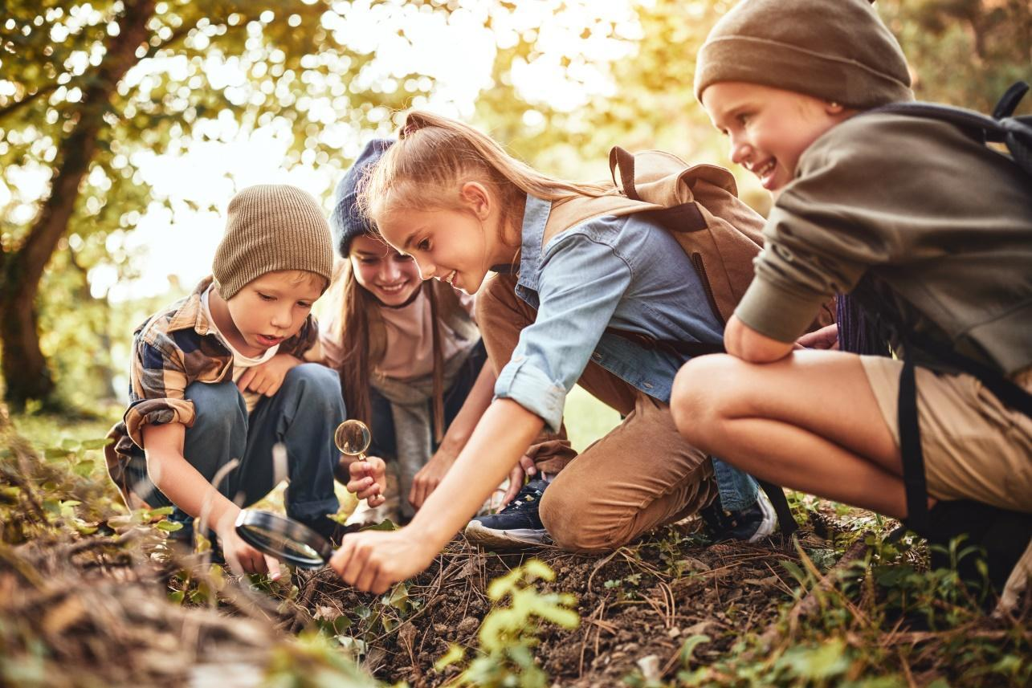
https://www.shutterstock.com/tr/image-photo/happy-children-boys-girls-casual-clothes-2029398614

Implementation

Timing | Instructions step by step
15 min | Pre-activity:  Ask students to:  - What is a natural resource?  - What is the source of the light?  - What is the importance of water in our life?  - What do you think is the purpose of this lesson?  (These questions are asked to the students to get their opinions.)
20 min | - Screen the photographs to explain what natural resources are  - Afterwards, the class is divided into groups and each group fills each container with an equal amount of soil.  - Each group is asked to plant a few grass seeds or place a small seedling in each container.  - Each group is asked to label the containers as follows and follow the directions:  Container 1: Watered and placed in sunlight  Container 2: Watered and placed in the dark  Container 3: No water and placed in sunlight  Container 4: No water and placed in the dark  Container 5: Watered sparingly and placed in sunlight  Container 6: Watered sparingly and placed in the dark  - Every few days, they use a magnifying glass to observe the soil in each container to look for signs of soil organisms like earthworms, insects, and microbial activity (fungal threads or bacteria)  - Measure the growth of the plants in each container.  - They record the presence of these organisms and any changes in soil structure or appearance also note the color, strength, and overall health of the plants in the notebook or observation journal day by day.
25 min | - Divide the class into individual groups.  - Recycling materials are distributed to each group. With these materials, large flowers are made on the board with the teacher’s support.  - Wıth the materials, the symbols of soil, water, air and sun that these flowers need to grow are created and placed around the flower on the board.  - Ask the members of the group to share their flower needs to ensure that all can understand the needs.  - Then, a word game created on this subject is played digitally.  (https://app.lumi.education/content/6512943bbe3de7d68a77c85e)
30 min | - Engage students to create a world with what they remember about sustainable agriculture by painting.

Hands on activity / farm - based learning

Timing | Description of activity
20 min  25 min  30 min | Activity 1: The class is divided into groups and each group fills each container with an equal amount of soil. Each group is asked to plant a few grass seeds or place a small seedling in each container. They water Container 1 and Container 2 daily to keep the soil moist, do not water Container 3 and Container 4. They water Container 5 and Container 6 sparingly. Ensure Container 1, Container 3, and Container 5 receive plenty of sunlight. Keep Container 2, Container 4, and Container 6 in a dark place. They record all observations in the notebook and Discuss how the presence of water and light affected both the plants and the soil organisms.  Activity 2: Students are divided into groups and recycling materials are distributed to their group. With these materials, a large flower is made according to the classroom plan with the help of the teacher. With these conditions, symbols of soil, water, air and sun for the growth of these flowers are created and the storage of flowers is placed on the board.  This word game consisting of words with special features are played digitally.  (https://app.lumi.education/content/6512943bbe3de7d68a77c85e)  Activity 3: They are asked to create a world with what they remember about sustainable agriculture by painting.

