LESSON PLANS

Module7: Game-Based Needs Analysis for Ecological Problems

Lesson Plan 1
FEELING THE GREENHOUSE
Proposed Students Age Range: 8-15
Purpose / Learning objectives
- The greenhouse is introduced to the students.
- Students are told about the importance of greenhouses to meet the food needs resulting from the increasing population and increased consumption.
Intersecting objectives
- To show students that fruits and vegetables can be produced more efficiently in greenhouses designed to eliminate the climate impact in regions and areas where the climate has a negative impact.
- To teach students to use arable land to the maximum extent through planned planting while protecting the grown product.
Facilitation
*Creating the greenhouse in the most efficient way by paying attention to the following factors:
- Light (the place where the greenhouse will be established should receive plenty of light)
- Temperature (greenhouse should be installed in hot places in terms of heating costs)
- Wind (must be in not windy areas, away from strong winds)
- Soil (must be rich in nutrients, have good water retention ability, and have humus)
- Direction (it should be directed to the south, southeast or southwest in winter cultivation)
- Irrigation water supply (water must be of good quality and easily supplied, there must be enough water)
- Economic activities (must be planned to make the most of the investment and obtain a certain income in return)

*Make sure everything is ready and safe before the trip.
*Let students get a little dirty in nature, gain experience, and feel nature.

Ideas for follow - up
- Students know what a greenhouse is, how and for what purpose it is established.
- They learn what benefits it provides to our lives.
- They understand the importance of the greenhouse for the increasing population.
- They understand the function and importance of factors such as soil, direction, light, wind, water and temperature due to the greenhouse.
Resources required
- Vehicle for sightseeing
- Greenhouse area
- Thermometer
- Wooden block/plate/lath/board
- Tarpaulin
- Small nail or wood staple
- Hammer
- Soil
- Greenhouse products to be tasted or given as gifts to students
Source / The day of the lesson: Materials & Class preparation
- Small greenhouse built during the trip:

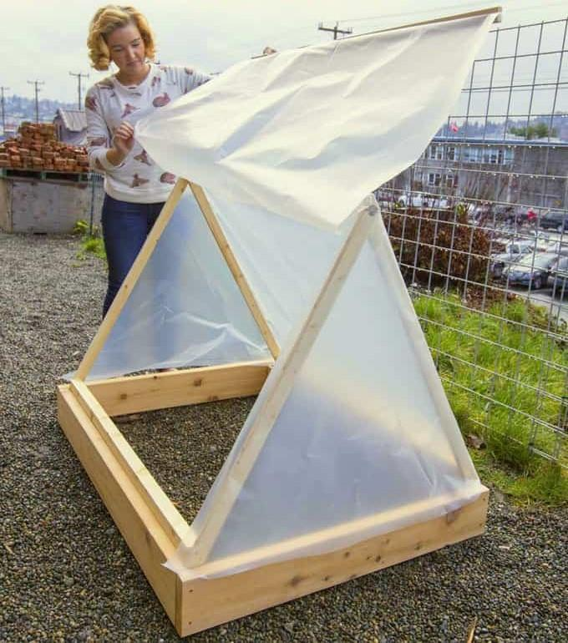
https://www.apieceofrainbow.com/21-amazing-diy-greenhouses/

Implementation

Timing | Instructions step by step
10 min | - Meeting and traveling to visit the greenhouse. (not included in the lesson duration)  - When arriving at the site, the students should first be asked "What is greenhouse and greenhouse farming?" Questions and opinions such as these are asked.  - Students are informed about greenhouses and greenhouse cultivation.
25 min | - Information about the greenhouses and what they do in the greenhouse is obtained from the authorized person who carries out the greenhouse cultivation.  - Depending on the condition of the greenhouse, students are divided into groups or not. Students are allowed in accompanied by an authorized person.  - When entering the greenhouse, attention is drawn to the temperature difference and the temperature is measured with a thermometer.  - The greenhouse is visited and the products grown inside are introduced with the presence of an authorized person.  - When going out, attention is drawn to the temperature difference again and the temperature is measured with a thermometer.
15 min | - If possible, children should taste the products grown in the greenhouse if they are food. If the products are plants or seeds, they are given as gifts to children for examination.
40 min | - Students are informed about the factors to be considered in greenhouse installation.  - Afterwards, the children start building a small greenhouse with the help of authorized people and teachers.  - Students are divided into groups and assigned.  - A small greenhouse sample is created and completed by everyone, to be taken to their classes.  - They return to school with the greenhouse sample.

Hands on activity / farm - based learning

Timing | Description of activity
90 min | Greenhouse tour and small greenhouse construction.

Module7: Game-Based Needs Analysis for Ecological Problems
Lesson Plan 2
LITTLE HANDS GREENHOUSE
Proposed Students Age Range: 8-12
Purpose / Learning objective
- Students learn the concepts of greenhouse and greenhouse cultivation.
- By sprouting seeds in the greenhouse and also outside of the greenhouse, they assimilate the use of the greenhouse.
Intersecting objectives
- They touch on geometry concepts while learning about greenhouse types.
- They learn about seeds and seed types.
- They observe the production process of food through the sprouting stage.
Facilitation
- When creating a greenhouse, geometric shapes and rules are simply emphasized and seed types are learned and felt.
- While students observe the stages of greenhouse production from seed to seedling, they are told the story of how the products they eat come to the table and the labor behind them.
- It should be ensured that all materials are ready (internet, soil, etc.) before the lesson.
- It should be taken into consideration that the students and the classroom will get a little dirty.
- Make sure you always use recyclable or recycled materials.
Ideas for follow -up
- Students experience what it is like to build a structure.
- They understand the food by seeing its source and production stage.
- Their awareness of food production and consumption increases.
Resources required
- Photos
- Geometric shape images
- Cardboard
- Plastic bag
- Greenhouse model (The small greenhouse made in the first lesson can be used.)
- Seed Types
- Bean seed
- Cotton
- Cardboard cup or suitable container (recyclable materials can be used, such as toilet paper roll)
- Water
- Water container or spray bottle
- Laptop, smart board etc.
- Internet
- Glue

Source / The day of the lesson: Materials & Class preparation
- Greenhouse type images:
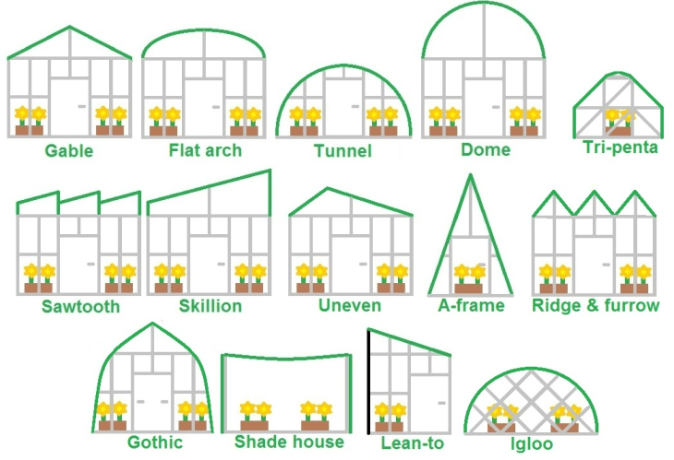

https://www.arch2o.com/10-most-inspiring-greenhouse-designs-around-world/

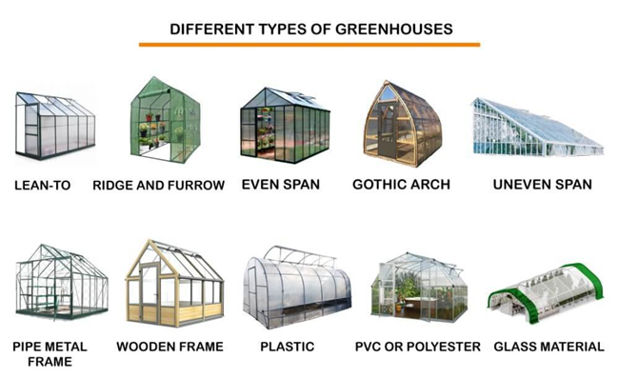
https://www.agriculturersrajput.com/2022/12/types-of-green-house.html

- Geometric shape images:

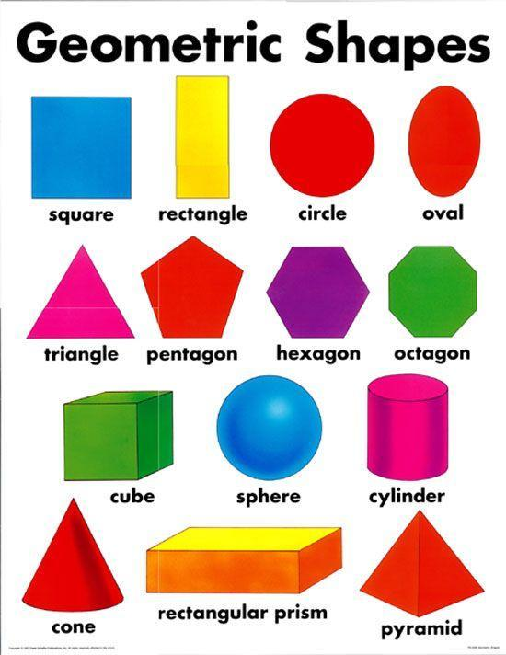
https://northccs.com/misc/four-basic-shapes.html

- Seed art examples:
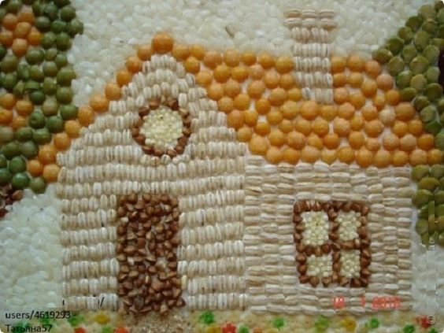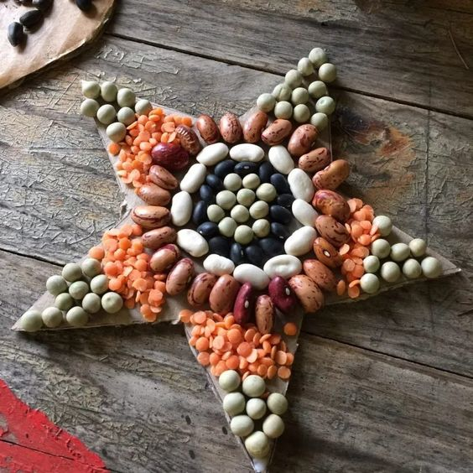
- https://www.howweelearn.com/seed-art-summer-craft/

- https://tr.pinterest.com/pin/16747829857165684/
- https://tr.pinterest.com/pin/33847434693471792/

- Bean sprouting video:
- https://youtube.com/shorts/-b_I_KL_1wU?si=qQQe0Y1oqShsFu4p
- https://www.youtube.com/watch?v=RTRW2Cf9U2U

- Bean Sprouting images
- https://www.twinkl.com.tr/resource/us-sc-366-bean-growth-sequencing-posters
- https://www.creciendoconmontessori.com/2016/10/ciclo-de-vida-de-la-planta-de-inspiracion-montessori.html

Implementation

Timing | Instructions step by step
18 min | - Students were asked "What is greenhouse and greenhouse cultivation?" Questions and opinions such as these are asked.  - Students are informed about greenhouses and greenhouse cultivation.  - Information about greenhouse types is given and supported by visuals. (Gable roof/gable greenhouses, bow roof greenhouses, glass greenhouses, plastic greenhouses, etc.)  - Geometry shapes are shown and their similarities with greenhouse types are discussed.
43 min | - Students are informed about seed types and the seeds brought to the classroom are examined.  - Students are allowed to examine the greenhouse model brought to the classroom and it is discussed.  - Students are divided into small groups and asked to draw first a geometric shape and then a greenhouse using the seeds.  - Each group creates a type of greenhouse by using geometric shapes and seeds.  - Students are told about the types of seeds to be grown in the greenhouse and how they are planted.  - Students are shown a bean sprouting video:  https://youtube.com/shorts/-b_I_KL_1wU?si=qQQe0Y1oqShsFu4p  - Students are shown the bean experiment video:  https://www.youtube.com/watch?v=QGFUWqSt-sI
22 min | To do the experiment they watched in the video:  - Each group of students is given 2 cardboard cups, a sufficient amount of cotton and bean seeds because they germinate easily.  - Each group moistens cotton in the cups and places the bean seeds.  - Students place one of the prepared seeds inside the greenhouse and the other outside.
7 min | - They prepare an observation journal to convey their observations of the bean seed sprouting process for both conditions.  - Students are asked to prepare a simple graph or table about the growth of the seed for future lessons.

Hands on activity / farm - based learning

Timing | Description of activity
40 min | - Designing geometric shapes and a greenhouse on paper using seeds.  - Preparation of seeds to be grown inside and outside the greenhouse in small cups.

