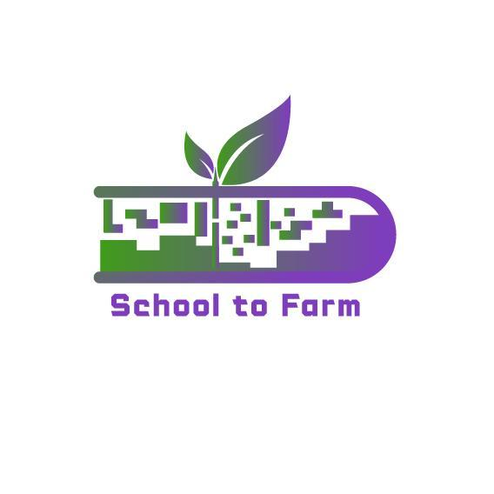

Using Farms as an Ecological and Pedagogical Education

Environment-Gamified-STEAM-Based Learning Approach

Model

**{SCHOOL TO FARM}**

**Good Practices in Türkiye**

2022-1-PL01-KA220-SCH-000088981

**Good Practice 1:**

**Ekol Nature College**

[**https://www.ekoltabiatkoleji.com/**](https://www.ekoltabiatkoleji.com/)

**Outdoor school for everyone!**

**“From the age of 3, our children will grow up where they belong, in the heart of Mother Nature.”**

We all set out on this path by saying that we have a lot to learn from nature; with our expert staff and project-based education model, foreign language education is given in our school. In our nature school, we carry out an education program enriched with sports, artistic, educational, social and cultural activities as well as modern education methods.

In our school, inspired by village institutes, we recognize and examine tree species in nature lessons, while we calculate the age of these trees in mathematics lessons.

In the social studies class, we make sourdough bread and bake it in a stone oven and share it with our friends in the shade of spruce trees. While developing our students' basic life skills, we are raising happy children who can stand on their own feet, produce, and have deep roots like walnut trees because they do not break with their essence that is beneficial to society.

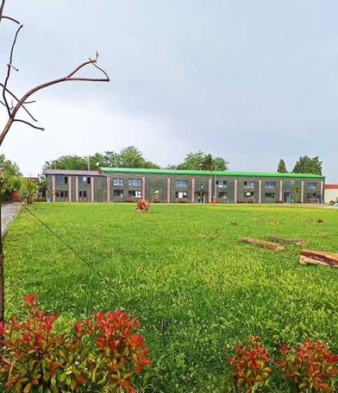 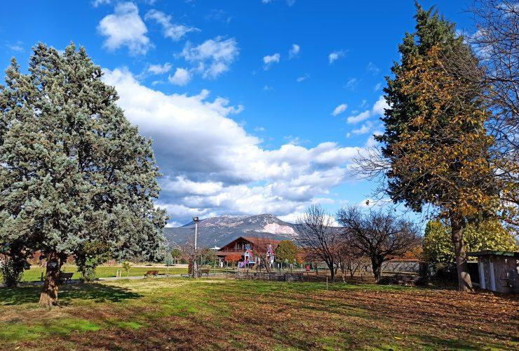

Pre-school

At Private Ekol Nature Kindergartens, studies similar to the Forest School are blended with the Reggio Emilia approach, and our children are offered a forest experience in our vast nature.

The main fundamental force is nature itself. Thanks to the unlimited space, silence and time in our nature, as in the Forest School, children are adequately supported in the development of their emotional stability, concentration skills and balance. Children who are in direct and constant contact with nature learn to take care of it and protect it.

The aim of the program is for children to explore, especially by working with natural materials, to have permanent and meaningful learning experiences rather than symbolic learning, and to have fun while learning. Pre-school education at Ekol Nature College is for happy children who know the right way to reach the wise and can notice their individual characteristics…

In addition to our basic education, we also support our education with nature education, physical education, modern dance, swimming, drama, English, French, music, visual arts, chess, ballet and mind games, branch lessons, and values education.

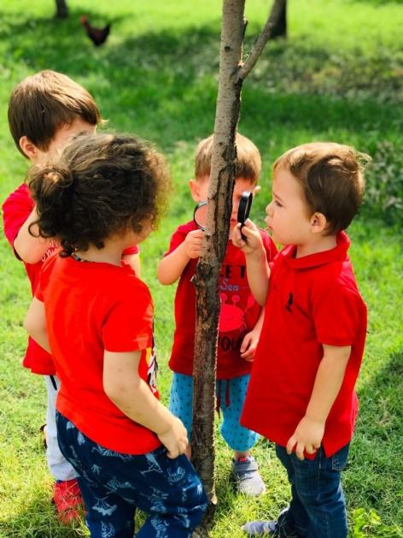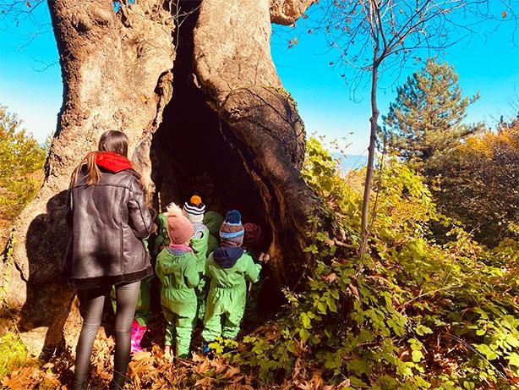

Nature Education in our Primary and Secondary Schools

As Ekol Educational Institutions, we have been happily implementing our Nature Education programs for more than 10 years with our educator stakeholders and students, who have devoted themselves to nature education, at all educational levels. Students, who have been educated at Ekol Nature College, connect them to the living and breathing cycles of the earth; they gain experience as individuals with leadership qualifications who learn to think critically and creatively about the future. As a basic need within the Nature program implemented in our school, our main goal is to raise ecologically literate individuals who know nature, know the limits of nature and have acquired sustainable living habits, are sensitive to the problems that concern the planet starting from their own environment, and take responsibility in the solution process of the problems. Based on the motto of "The information that cannot be used is not ours", we aim to enable our students to gain the necessary achievements in primary school and to use what they have learned in their school and out-of-school lives.

Secondary School Nature Education aims to contribute to children's becoming individuals who develop empathy with other living things in nature and are aware of how their choices in daily life affect nature, in order to gain ecological literacy skills to children. In the program, which was prepared with an interdisciplinary approach, it was aimed to prevent children from alienating from nature and to make them realize that they are one with nature and to internalize it. The activities designed within the scope of our Nature Program are designed to encourage children to understand the systems in the natural flow of the planet, to shape their life behaviors without disturbing the functioning of these systems, to connect with nature and to approach nature with compassion. The secondary school nature education program is implemented in different courses or within the scope of club activities during an academic year.

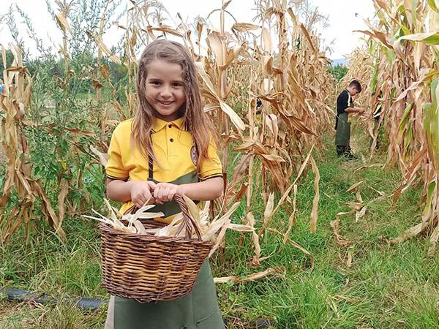 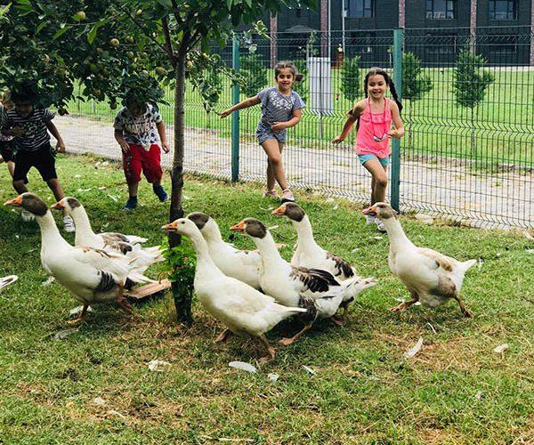

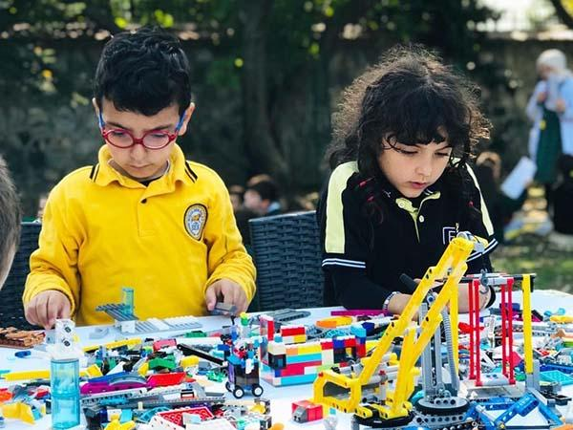 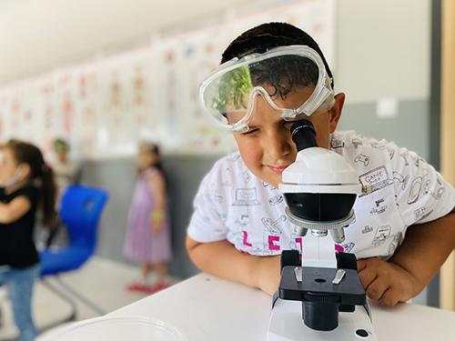

Living School

At times outside of our academic program; we have implemented the concept of "Living School" so that our students can get to know and discover themselves and spend quality time with their families. The “Living School”, where our students can carry out social, cultural and sports activities together with their families, is open to the use of our students and parents on weekends.

In our campus designed in accordance with this concept; from seasonal vegetable production to various types of poultry; many activities, from baking bread in a stone oven to making natural yoghurt, to conversations and concert events, can be held as a family. Like this; our students, who realize their talents and the pursuits they enjoy doing, not only get to know themselves but also experience the happiness of spending time with their families.

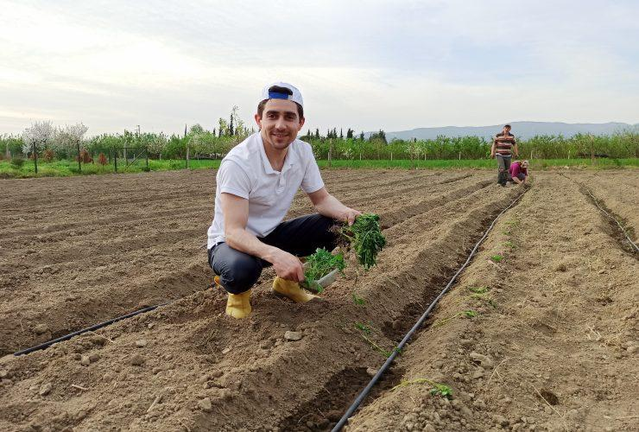

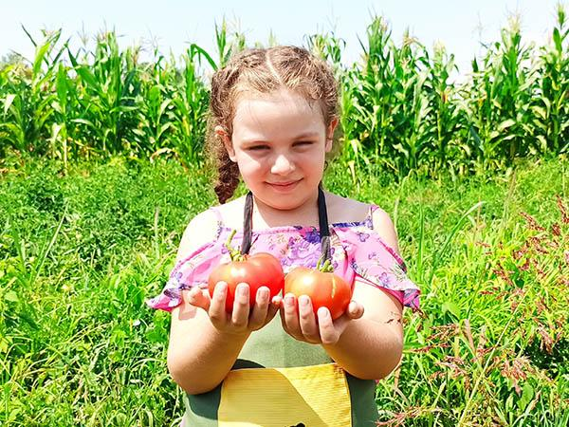 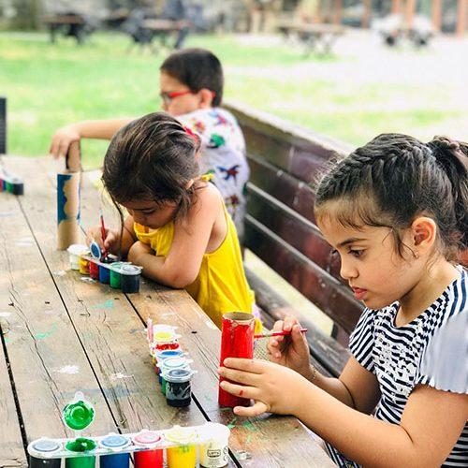

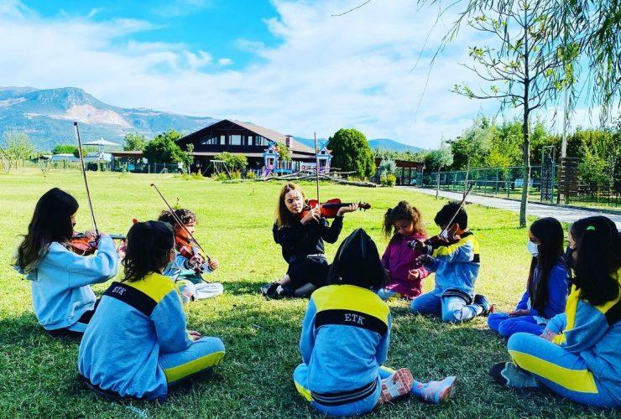

**Good Practice 2:**

**Tema Foundation Education Programs**

<https://www.tema.org.tr/calismalarimiz/egitim>

The reason for the existence of TEMA Foundation is to protect and protect life, that is, the land. Because the soil is the home of all of us, the direct or indirect source of 95% of our food, the source of endurance of our habitats. As the largest carbon sink after the oceans, soil is also an important actor in the fight against the climate crisis. If we have land, we have forests, agriculture, pastures and livestock.

Our horizon is to be a voluntary, conscious, pioneering, international and respected Non-Governmental Organization that works on the basis of science for the protection of all natural assets, especially our lands, with the principle of sustainable living, believes in social peace coming from the soil, integrates with the people, has a say in the future of the country and the world.

Two respected businessmen of Turkey, Hayrettin Karaca and A. Nihat Gökyiğit, decided to introduce the concepts of environment and sustainability, which are still very new in the international arena, to Turkey and to organize the nature conservation, which they dedicate their lives to and on September 11, 1992, they established the Turkish Foundation for Combating Erosion, Afforestation and Conservation of Natural Assets.

In a short time, the volunteers and supporters of the TEMA Foundation began to increase.

-Pasture and Soil laws were enacted in Turkey.

-Today, there is at least one forest in Turkey's 81 provinces that was created thanks to TEMA Foundation donors. Since 1992, we have planted 37.3 million saplings in an area the size of 43,500 football fields. We planted 700 million acorns in an area the size of 22,000 football fields.

-We have reached approximately 6 million children through nature education and awareness activities. We have developed modern nature education programs for all levels of education and training. Millions of children and hundreds of thousands of adults benefited from our education programs and became acquainted with the concept of ecological literacy. We have millions of children who received nature education from the TEMA Foundation 20-25 years ago, and who are our volunteers, donors and supporters today.

- We have hundreds of thousands of volunteers and supporters in every province of Turkey, 81 provincial representatives, responsibilities in more than 300 districts, and a Young TEMA Community in nearly 150 universities.

We have realized 368 rural development, protection and afforestation projects so far.

-We reached more than 230 thousand teachers and more than 35 thousand public officials with environmental seminars.

-Every step we take to protect natural assets; There are scientific reasons for the benefit of nature under every objection we make. For this reason, we have won 179 of the 305 lawsuits we have opened/were involved in. Dozens of cases that we are involved in are ongoing.

-We brought nearly 100 books about the environment to the public.

-Today, we have a perception of the TEMA Foundation, which is known by almost all of the society and identified with volunteerism, trust, trees, nature and the struggle to protect natural assets. As a foundation, we received the "Land for Life" award in 2012, which was given for the first time in the world under the leadership of the United Nations Secretariat to Combat Desertification (UNCCD) and for which many NGOs and states were nominated. We are honored to represent Turkey in the managements of important institutions such as the European Environment Bureau, DRYnet and the UNCCD Civil Society Panel. We still have a lot of work to do and a long way to go in order to protect natural assets. We continue to work for nature with the support of our volunteers and donors.

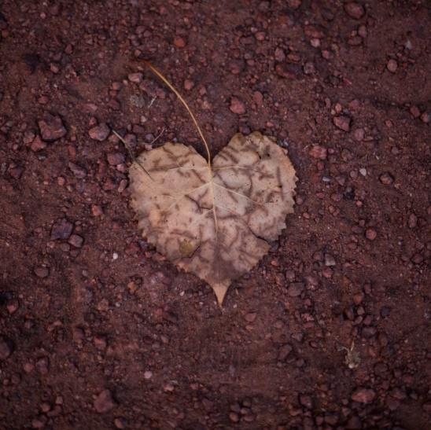 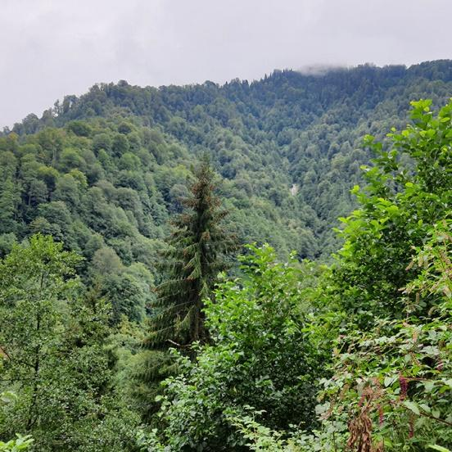

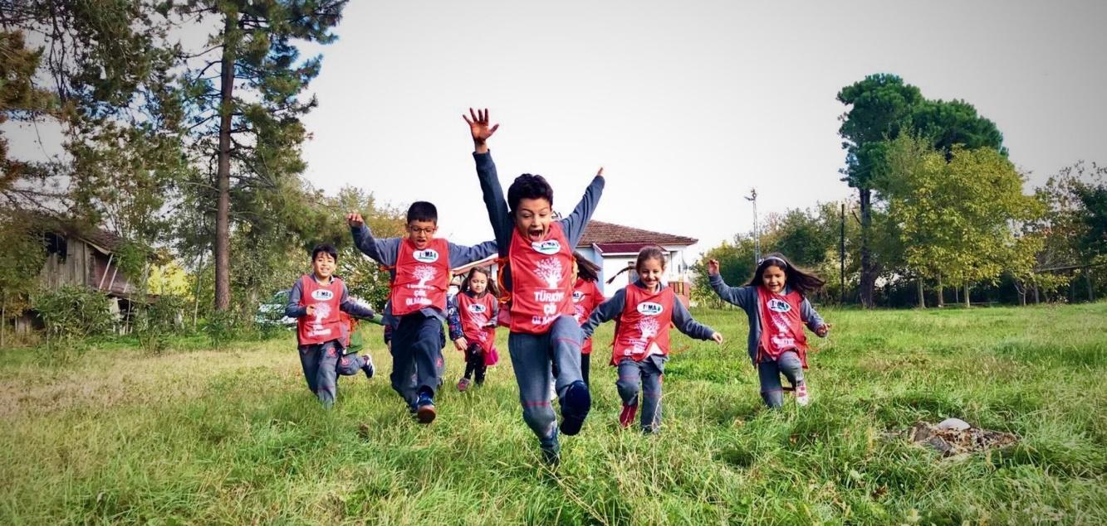

**Educational Studies**

Working titles:

**Nature Education Programs:** <https://www.tema.org.tr/calismalarimiz/egitim/doga-egitim-programlari>

**Education Projects:** <https://www.tema.org.tr/calismalarimiz/egitim/egitim-projeleri>

**Informative Websites:** <https://www.tema.org.tr/calismalarimiz/egitim/bilgilendirici-web-sitelerimiz>

**Turan Demiraslan Scholarship:** <https://www.tema.org.tr/burs>

**Movies:** <https://www.youtube.com/watch?v=PLgd-BqSpLU&list=PLCLBtPTlhcn7U2s3eLNtNYFElZC88B7TC>

**Songs:** <https://www.youtube.com/watch?v=iL-TwhJT5mw&list=PLCLBtPTlhcn77hQynKgjcGlSB78WjWOJH>

Here we will only briefly touch on two examples from two topics:

**Nature Education Programs:** Educational programs were created with the themes of tiny, child, middle school and high school.

The Tiny TEMA Education Program is designed with the aim of enabling preschool children to spend more time in nature, making observations, exploring nature with a sense of curiosity, and strengthening their ecological literacy skills.

The program, whose main purpose is to raise awareness of children on ecological literacy, is implemented in 81 provinces of Turkey. With the program, which offers teachers a total of 63 activities, 53 face-to-face and 10 online, to be applied outdoors and in the classroom, children are supported to connect with nature.

Thanks to the educational materials prepared as broad as possible on topics such as soil, water assets, biodiversity, ecosystem, weather, observation in nature, and sustainable life, and activity instructions under each topic, teachers can organize activities prepared in accordance with their annual education programs in their classrooms or outdoor. It can be easily applied in the air. In addition, a portal including the Little TEMA Training Program was launched so that teachers can easily access all training content. (tiny-yavrutema.org)

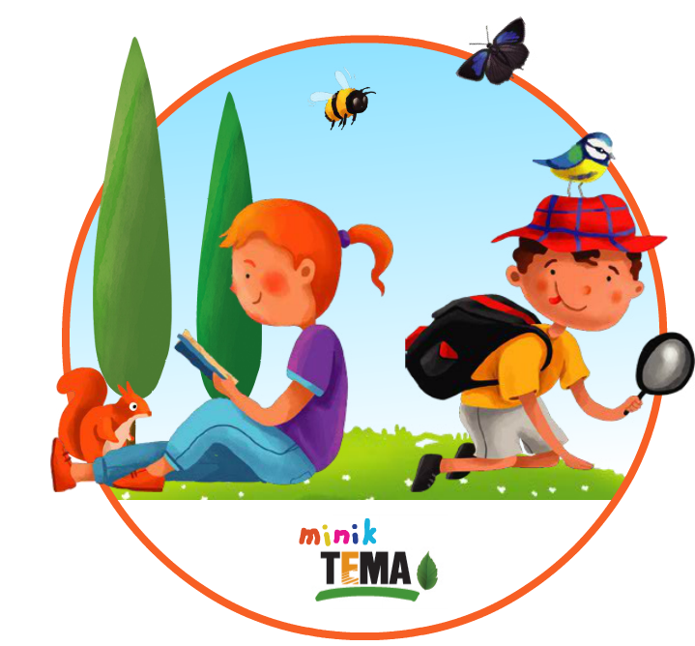

The Kid TEMA Education Program is designed to enable primary school children to spend more time in nature, to make observations, to explore nature with a sense of curiosity, and to strengthen their ecological literacy skills.

Children's bonding with nature is supported by the program, which offers teachers a total of 84 activities, 74 of which are face-to-face and 10 online activities, to be applied outdoors and in the classroom.

Thanks to the educational materials prepared as broad as possible on topics such as soil, water assets, biodiversity, ecosystem, weather, observation in nature, and sustainable life, and activity instructions under each topic, teachers can organize activities prepared in accordance with their annual education programs in their classrooms or open spaces. It can be easily applied in the air. In addition, a portal including the Kid TEMA Training Program was launched so that teachers can easily access all training content. (tiny-yavrutema.org)

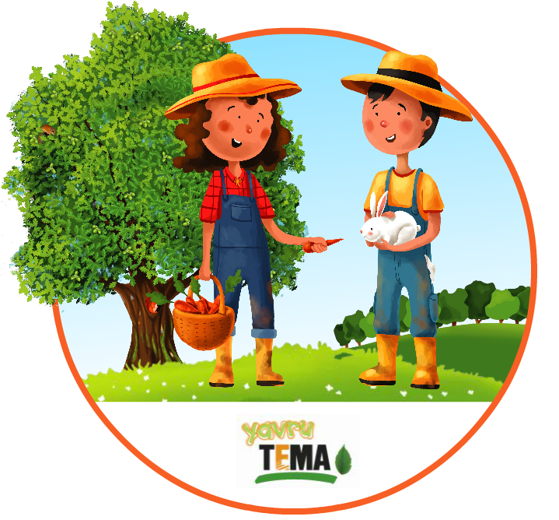

**Education Projects:** The projects are titled as follows; Nature Explorer, Tree Fellowship, Zero Waste, Our Home is Earth, Climate Change Education and Awareness Project, I Discover Nature, Completed Projects

The I Discover Project has been prepared for preschool, primary, secondary and high school children and youth. It has been developed with the aim of helping children and young people in Avcılar district recognize nature starting from their immediate surroundings and rediscover nature with a sense of curiosity, connect with nature, make observations, raise awareness about biological diversity, and ultimately increase their ecological literacy skills.

Within the scope of the project, educational materials such as presentation, observation wheel (bird, leaf and butterfly observation), observation brochure (soil, insect, tree, bird, butterfly and cloud observation), posters were designed. Educational activities are implemented in schools with the support of teachers. Within the scope of I Discover Nature Project, activities were developed and materials were designed for pre-school and primary school levels. With the educational activities held in Avcılar district, approximately 30,000 children were reached in 1,041 classrooms at pre-school and primary school levels.

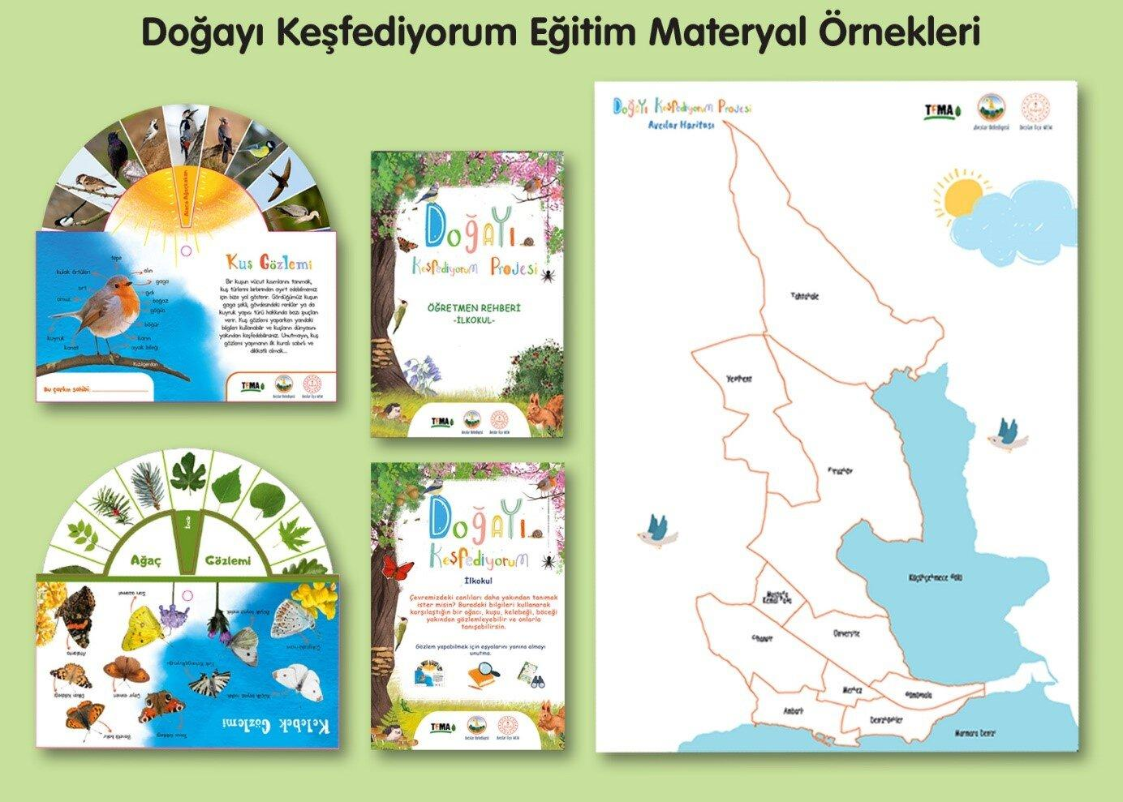

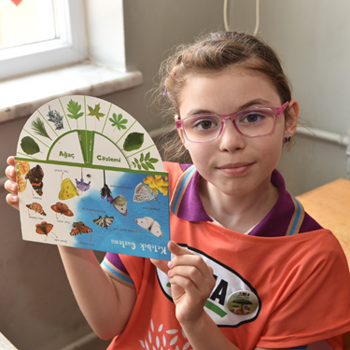

With the Tree Fellowship Project, Increasing the experiential experiences of the children going to primary school; it is aimed to get acquainted with the concepts such as ecosystem, endemic plants and biodiversity, to observe the seed growing process and to gain awareness on "Forest Ecosystem and Biological Diversity". It is aimed to contribute to the fight against erosion with the "Hayrettin Karaca Tree Brotherhood Memorial Forest" created at the same time.

Within the scope of the project, educational content and materials were developed for primary school children in order to raise awareness about relations in nature, forest ecosystem, seed growing and observing, biodiversity and endemic plants.

Practices are carried out with short-term activities that contain educational materials such as posters, presentations, observation notebooks, observation boxes, leaf wheels and tree cards and are specially prepared for primary school children. In addition, with the project, it is aimed that children will be able to experience the plant growing process by enabling them to grow their own saplings from seeds specific to their region.

Within the scope of the project, approximately 45,000 children in 81 provinces of Turkey were reached in 7 years. Approximately 90,000 saplings in total, together with the saplings in the 7 memorial forests, which were created, of which approximately 45,000 were the saplings grown by the children themselves within the scope of the project, came together with the soil. Our 7,904 volunteer runners, who run for charity for the Tree Fellowship Project, have contributed to the project by creating a total of 5,841,423 TL so far.

